TITLE OF RESEARCH
(Times New Roman, capital letters, 14pt, centered, bold)

Author’s name and surname¹, Author’s name and surname ²*, and Author’s name and surname ³
(Times New Roman, 10pt, centered)

¹Affiliation of Author 1 (Times New Roman, 10pt, centered)
^{2*}Affiliation of Author 2 (Times New Roman, 10pt, centered)
³Affiliation of Author 3 (Times New Roman, 10pt, centered)

E-mail ²*corresponding author: xxxxxx@gmail.com

ABSTRACT (Times New Roman, 12 pt, bold, all caps, justify)
An abstract should include a summary of what the study is all about. It will summarise between 250- 300 words of the study or research, 10 font size, Times New Roman, justified, single line spacing. Content consists of the introduction (including problem background and aims of the research), research objective, research methodology, results/findings, conclusions, and implication of research. Text in Times New Roman, single spacing, 250-300 words, 11 font size. Text text text text text text text text text text text text text text text text text text text text text text text text text text text text text text text text text text text text text text text text text text text text text text text text text text text text text text text text text text text text text text text text text text text text text text text text text text text text text text text text text text text text text text text text text text text text text text text.

Keywords: Keywords regarding the research contains of maximum 5 words, written with 10 font size and separated with semi-colon.

- INTRODUCTION (headlines: Times New Roman, bold, 12pt, all caps)
In conjunction with the SWAT2017 theme, papers of relevant topics within the conference theme are invited for oral/poster presentations. Authors are requested to submit an extended abstract not exceeding four (4) pages in English.
The extended abstract must include the title, author(s) introduction, material and methods, results and discussion, conclusion and references. The manuscript should be prepared on an A4-sized paper with 25 mm margins on all sides and typed with single spacing using size 12 Times New Roman font. All illustrations must be prepared inside of the main text. Selected papers will be published in the special issue of the Malaysian Journal of Soil Science (MJSS).

- OBJECTIVES (headlines: Times New Roman, bold, 12pt, all caps)

- METHODOLOGY (headlines: Times New Roman, bold, 12pt, all caps)

The methodology must be clearly stated and described in sufficient detail or with sufficient

references.

- RESULTS AND DISCUSSION (headlines: Times New Roman, bold, 12pt, all caps)
The findings and arguments of the work should be explicitly described and illustrated. All the tables, images and figures should be centered. Figures and images should be numbered and figure headers should be placed under the figure or image; as for the tables, they should also be numbered and the table header should be placed at the top. References (if any) of the tables, figures and images should be presented right under the tables, figures and images in the form of author surname and publication date.

4.1 Equations
Equations should be centered and numbered consecutively, as in Eq. [1]. An alternative method is given in Eq. [2] for long sets of equations where only one referencing equation number is wanted.
(1 line spacing here)
 | 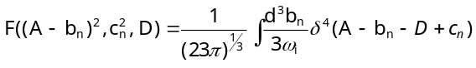
where, | (1 line spacing here)
 | 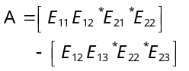

  - List
Lists can be provided using either numbers or bullets:
- List item 1 like this;
- List item 2 is an example of a longer list item that wraps to a second line, where the second line is indented. The example for bulleted items like this:
- List item 1
- List item 2

  - Tables and figures
Tables and figures should appear in one column of a page and be numbered consecutively. Figures and texts may appear on the same page, and a centered caption should appear directly beneath the figure. It is preferable that figures be mounted in portrait style and figure captions are no longer than two lines. On figures showing graphs, both axes must be clearly labeled (including units if applicable).
Tables should be designed to have a uniform style throughout the paper, following the style shown in Table 1. Table captions should be in 10pt “Time News Roman” bold, centered, and the texts in Table should be set in 9pt “Time News Roman” font.

Table 1. Caption heading for a table should be placed at the top of the table and within table width
(Use “time news roman” font, size 10pt, No spacing after table title)
 | A | B | C | D
A | Aa | Ab | Ac | Ad
B | Ba | Bb | Bc | Bd
C | Ca | Cb | Cc | Cd
D | Da | Db | Dc | Dd
E | Ea | Eb | Ec | Ed

Authors are advised to prepare their figures in either black and white or color. Please prepare the figures in high resolution (300 dpi) for half-tone illustrations or images. Pictures must be sharp enough otherwise they will be rejected. Figures must be originals, computer-generated or drafted, and placed within the text area where they are discussed. Figure 1 shows one example. Figure captions should be in 10pt “Time News Roman” font, bold, centered. When applicable, the texts in graphs, illustrations or images should be set in 8pt “Time News Roman” font.

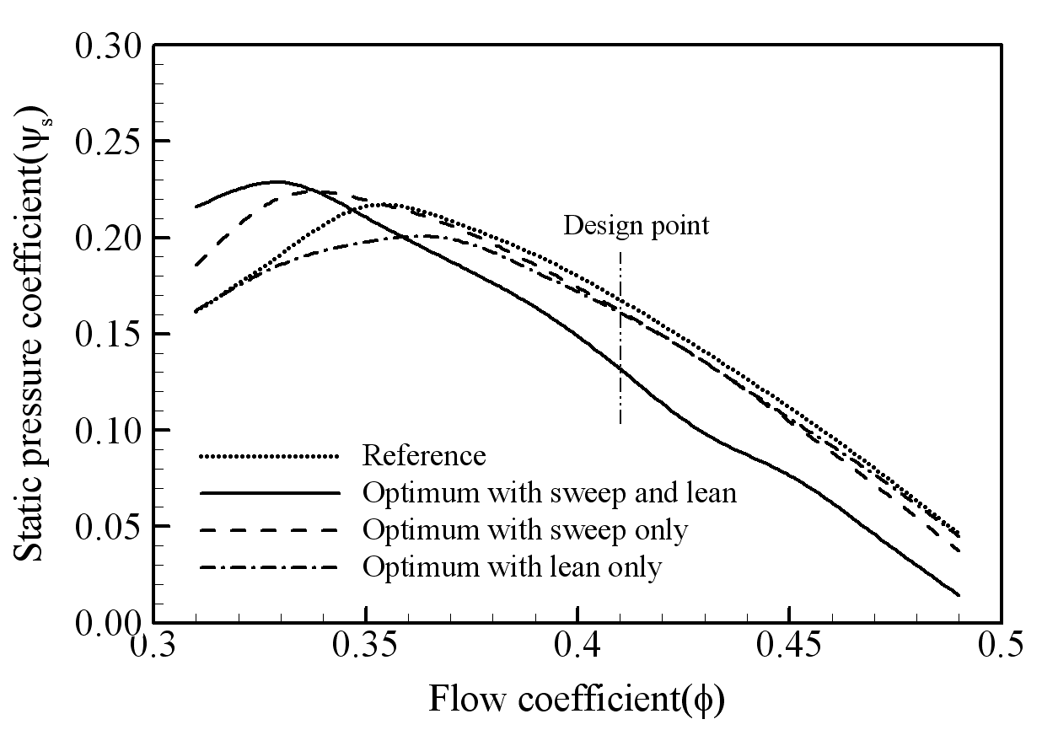
Figure 1. The caption heading for a figure should be placed below the figure and within figure/illustration width. (Use “Time News Roman” font, size 10pt, no spacing between title and figure)

  - Footnotes
Footnotes are denoted by a character superscript in the text b.

  - Units
Use either SI (MKS) as primary units. English or CGS units may be used as secondary units (in parentheses). Avoid combining SI and CGS units. This often leads to confusion because equations do not balance dimensionally. If you must use mixed units, clearly state the units for each quantity that you use in an equation. Do not mix complete spellings and abbreviations of units. Spell out units when they appear in text.

- CONCLUSION (headlines: Times New Roman, bold, 12pt, all caps)
Conclusions should include (1) the principles and generalisations inferred from the results, (2) any exceptions to, or problems with these principles and generalisations, (3) theoretical and/or practical implications of the work, and (5) conclusions drawn and recommendations.

- IMPLICATION (headlines: Times New Roman, bold, 12pt, all caps)

- REFERENCES (headlines: Times New Roman, bold, 10pt, all caps)
References should be listed arranged in alphabetical order beginning with the author’s names and initials, followed by the year of publication, title of periodical, volume and page. Example:
Parlange, J.Y., R. Haverkamp and J. Touma. 1985. Infiltration under ponded condition: 1. Optimal analytical solution and comparison with experimental observation. Soil Sci., 139: 305-311.
In the text, references should be cited with the name of the author(s) with the year of publication in parenthesis, e.g., Philip (1957), Taylor and Baker (1986), Smith et al. (1987).

Total no. of references must not exceed 15. Resources that have been presented inside [ ] in the text with numbers should be listed according to their order in the text. References that have been presented in the references list should be prepared in a format according to the reference type shown below:

If the reference is an article; 1. Pommiera, S., Chenub, D., Quintardb, M. ve Lefebvre, X., (2007). Modelling of moisture-dependent aerobic degradation of solid waste, Waste Management, 28, 7, 1188-1200

If the reference is a book; 2. Li, G., Hart, A. ve Gregory, J., (1998). Flocculation and sedimentation, 295, Technomics Press, Lancaster PA.

If the reference is a chapter of a book; 3. Blackburn, T., (1998). Flocculation and sedimentation in Li, G., Hart, A. ve Gregory, J., eds, Physical Processes, Technomics Press, 29-45, Lancaster PA.

If the reference is a declaration; 4. Yıldız, Ş., Balahorli, V., (2009). Treatment of the waste water seepage with
membrane systems: Istanbul example, Membrane Technologies and Implementation Symposium, Istanbul –
Turkey.

Margins: 2.5cm for top, bottom, left and right

b

